COMPILER DESIGN LABORATORY
LEXICAL ANALYZER PROGRAMS (1–10)
EXPERIMENT RECORD
Department: Information Technology
Subject: Compiler Design
Subject Code: CSA1410
Submitted by: Keerthana.G
Register Number: 192521446
Exp. No. 1
Write a LEX specification file to take input C program from a .c file and count tthe number of characters, number of lines & number of words.

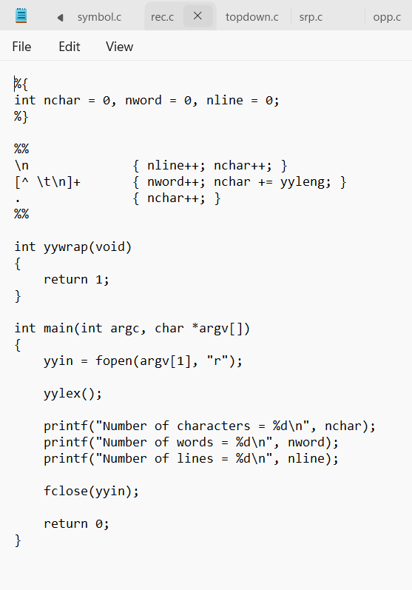

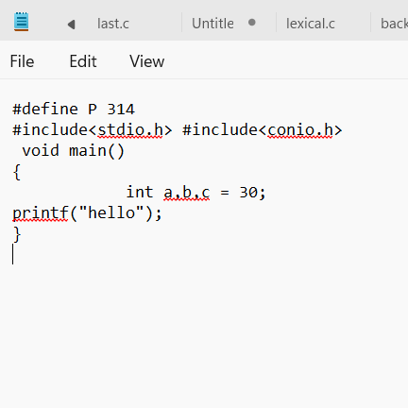

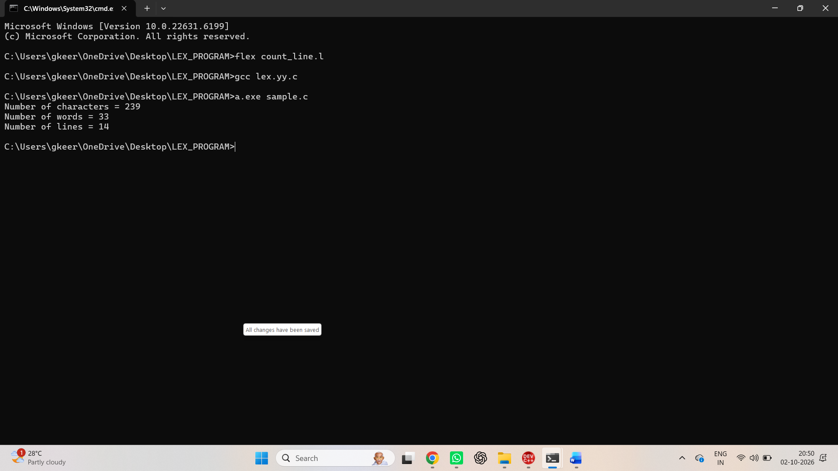

Exp. No. 2
Write a LEX program to print all the constants in the given C source program file.

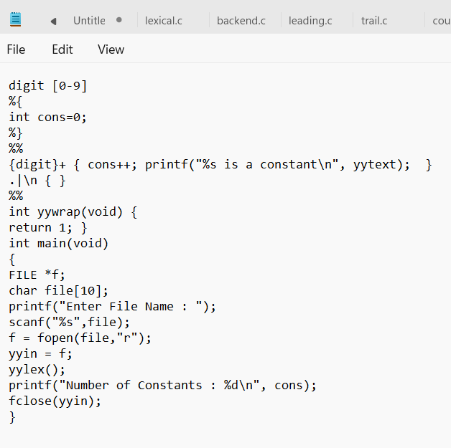
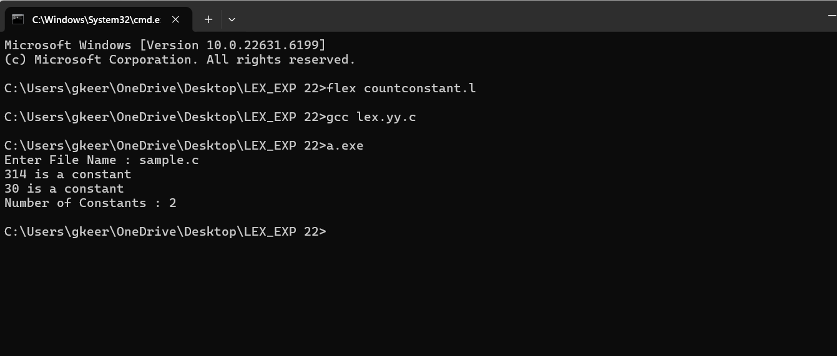

Exp. No. 3
Write a LEX program to count the number of Macros defined and header files included in the C program.

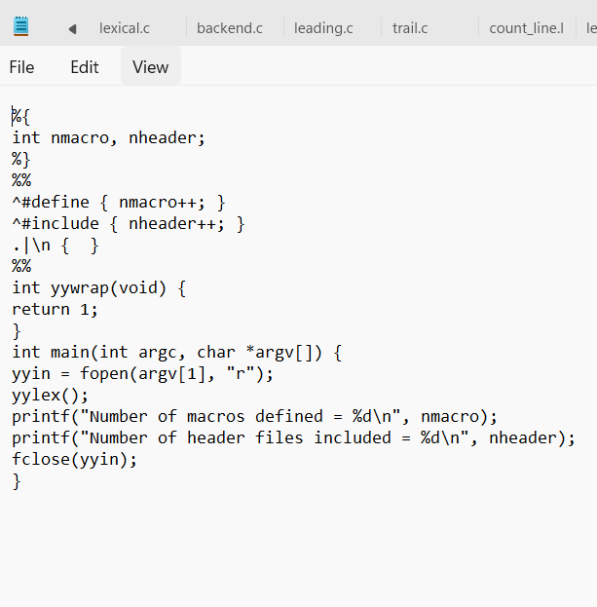
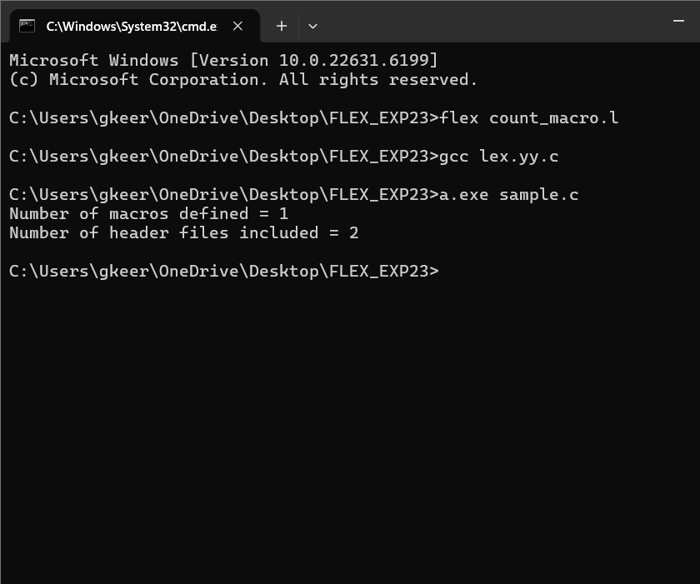

Exp. No. 4
Write a LEX program to print all HTML tags in the input file.

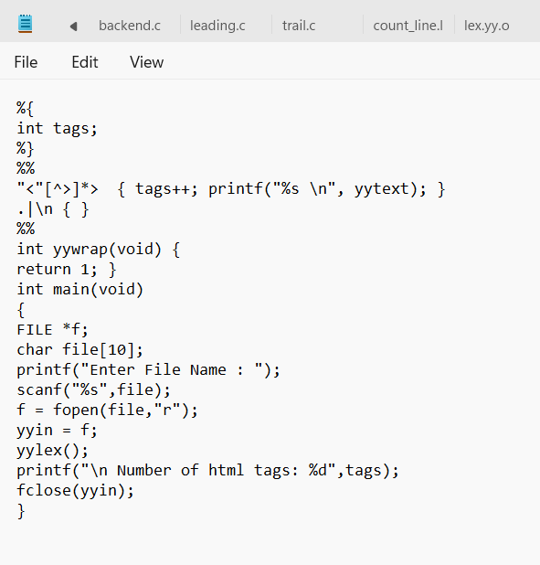
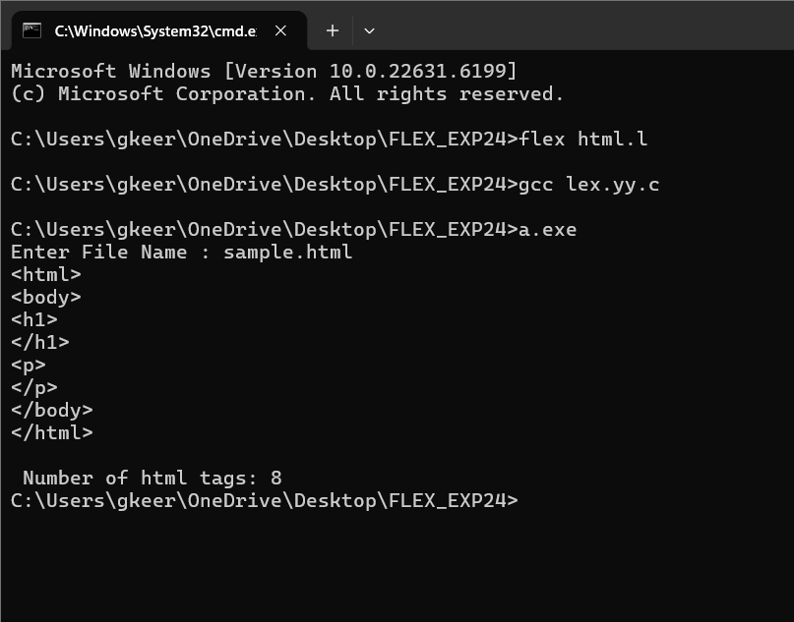

Exp. No. 5
Write a LEX program which adds line numbers to the given C program file and display the same in the standard output.

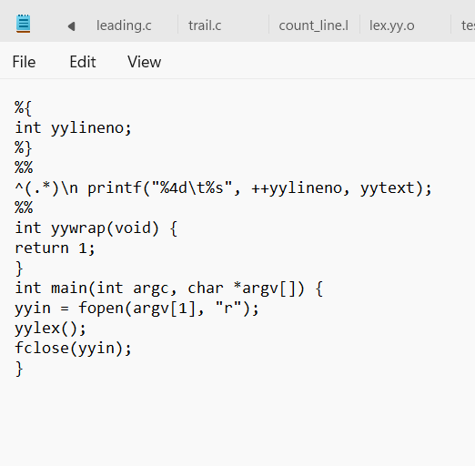
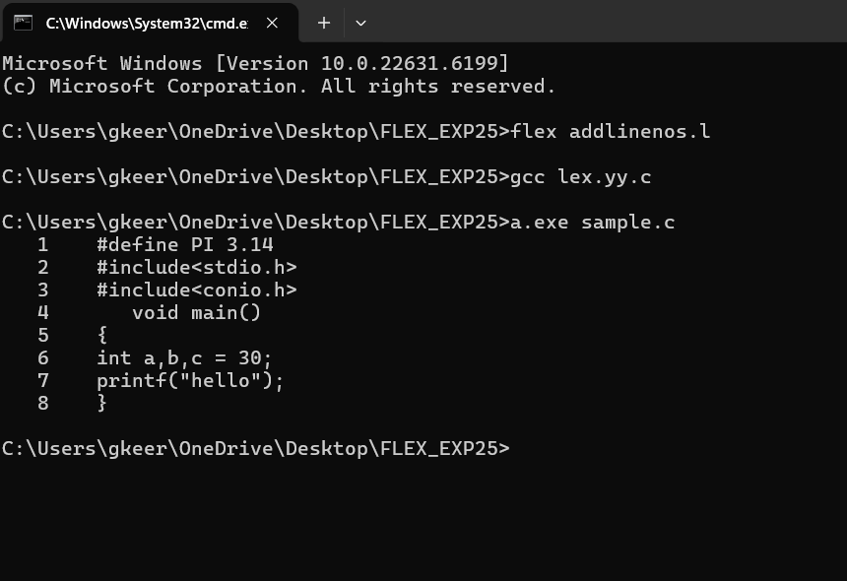

Exp. No. 6
Write a LEX program to count the number of comment lines in a given C program and eliminate them and write into another file.

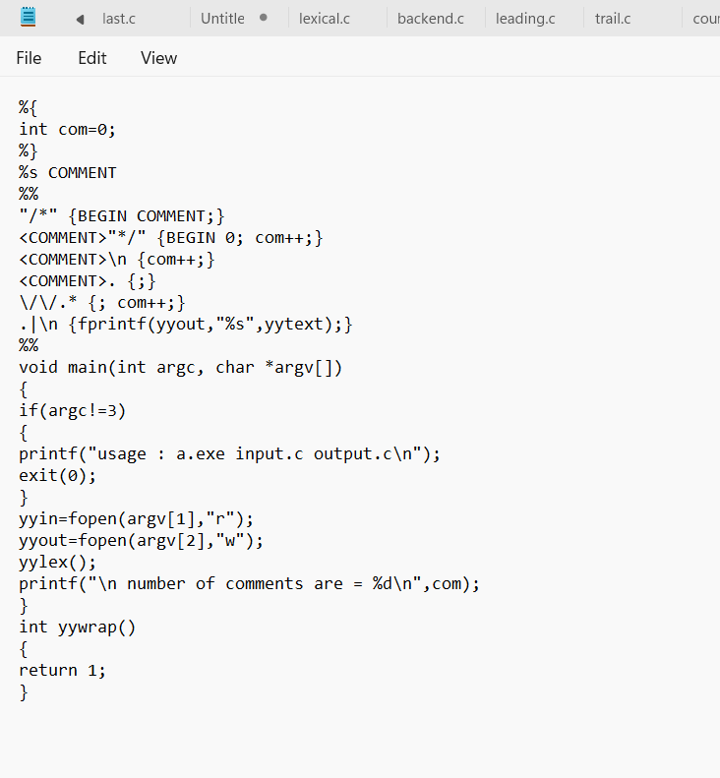

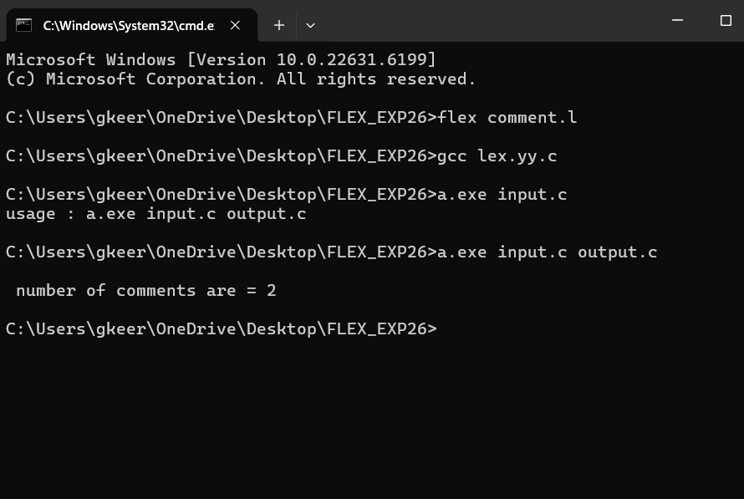

Exp. No. 7
Write a LEX program to identify the capital words from the given input.

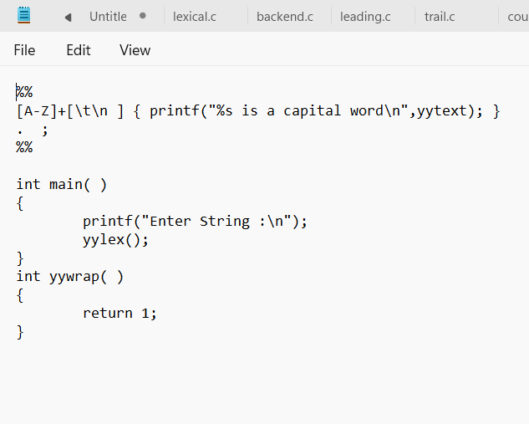

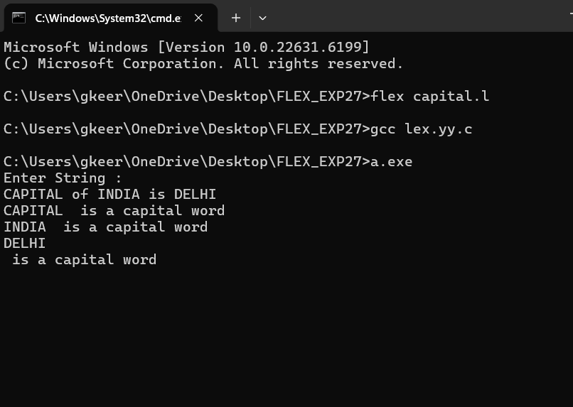

Exp. No. 8
Write a LEX Program to check the email address is valid or not.

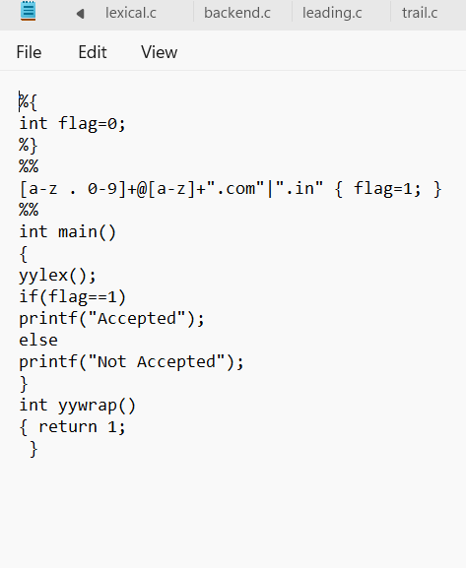
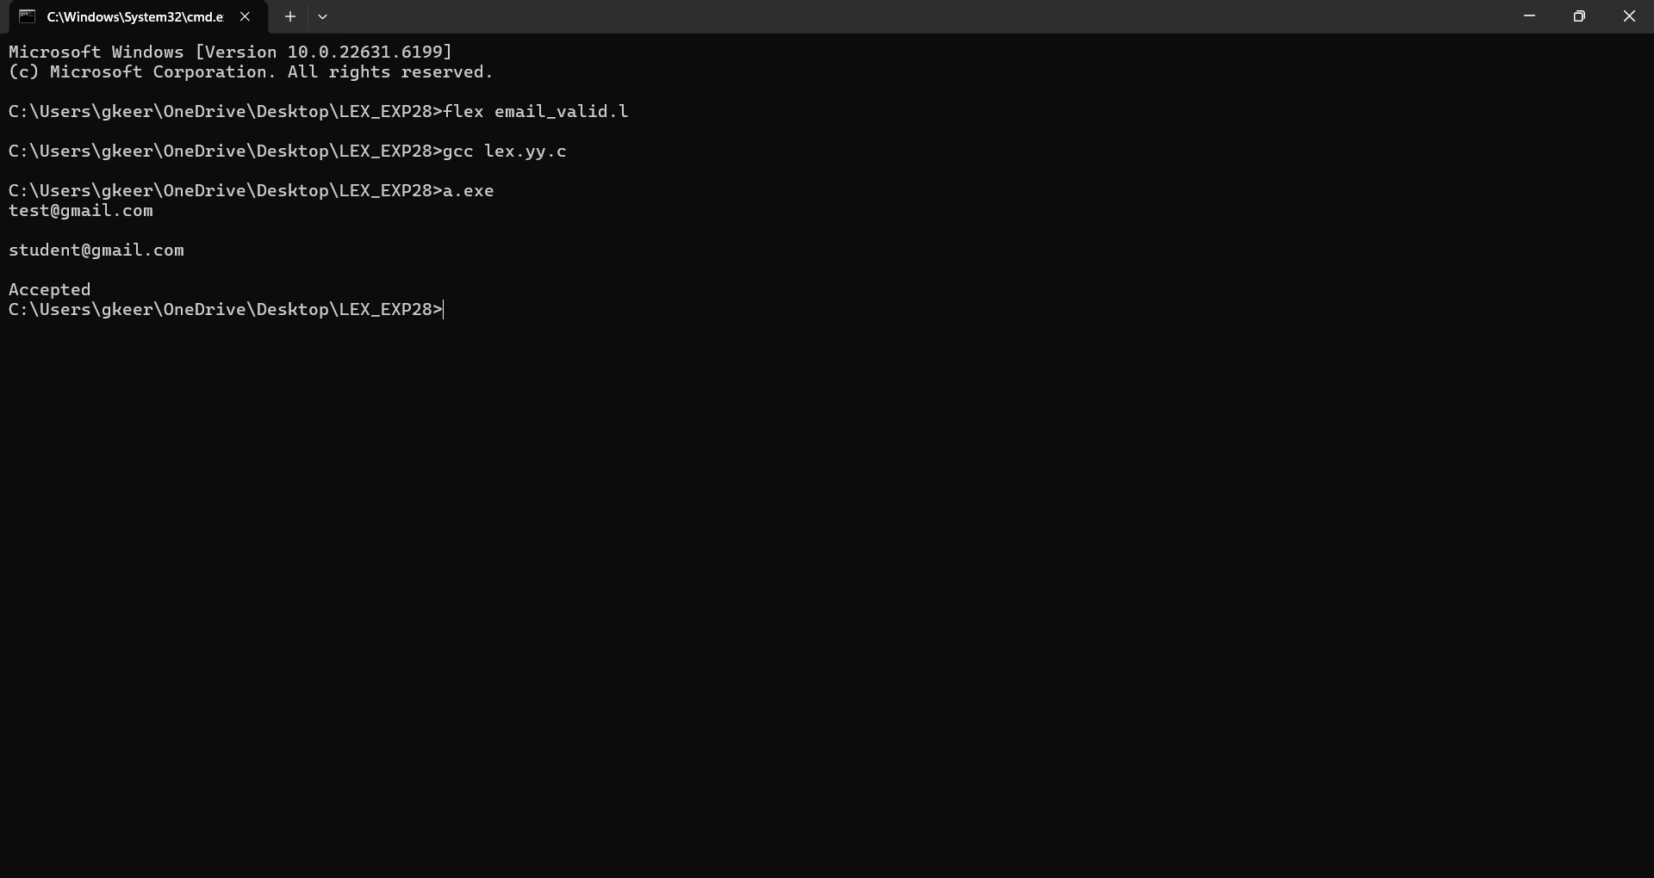

Exp. No. 9
Write a LEX Program to convert the substring abc to ABC from the given input string

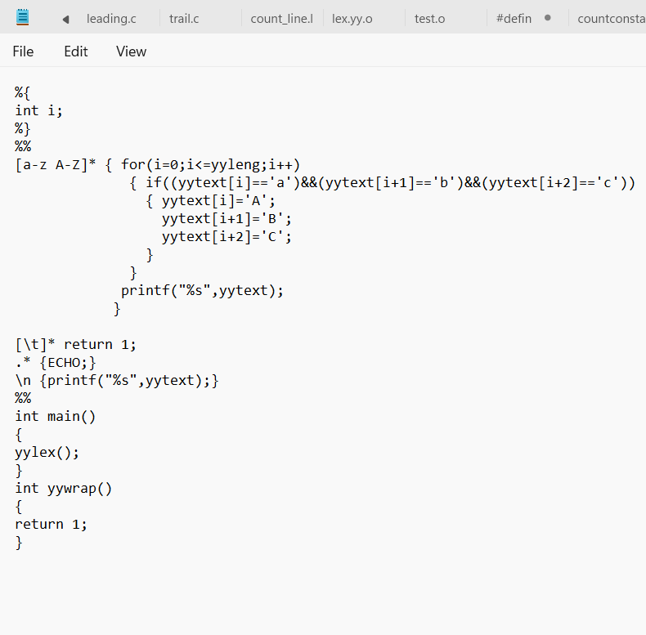
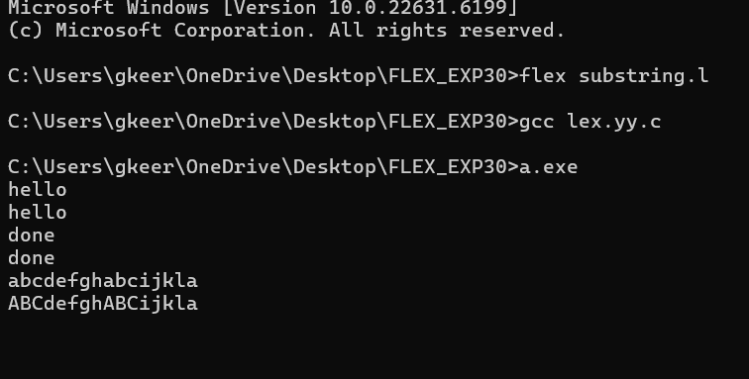

Exp. No. 10
Implement a LEX program to check whether the mobile number is valid or not.

